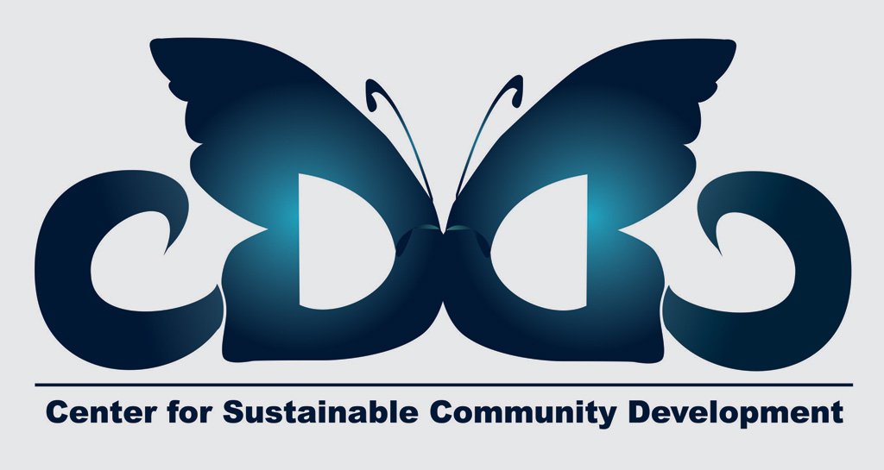

“INSPECTORS for ACCESSIBILITY” Training Course, 1-8 February 2015, Craiova-Romania

ACCESSIBILITY ASSESSMENT CHECKLIST
FOR YOUTH PROJECTS WITH MIXED ABILITY GROUPS
Prepare a checklist to identify accessibility criteria in which this youth project is succeeding as well as those areas that need improvement. The first step to being fully inclusive is to know whether your project venue is physically accessible as possible for your specific mixed ability group. That means we should check below criteria all over again for every different group with different needs. This checklist will help you providing equal opportunities for young people with and without disabilities during a youth project. Then you will use this checklist to INSPECT our hotel in terms of accessibility. So let’s start to think and discuss what shall you check in below parts of the hotel.

 | Participants with visual impairments: | Participants with hearing impairments: | Participants with physical disabilities | Participants with learning difficulties
Meeting Room/Plenary Room: | - Having guidelines in Braille, at the entrance in the working room  - Movement detectors  - İf you are planning to give different tasks for the activities, ask the participants to bring their mobile phones/tablets/computers with them so that you can send the tasks and they have access to the tasks in the same time as the other participants (without having someone else reading the information) ` | - Using subtitles if possible  - Having the chairs placed in the circle so that the participant can face the interpreter  - Having the information typed and projected  - Having one interpreter per participant so that the participant can ask additional questions if the information is not clear  - Working with the interpreter in advance – explaining concepts that are included in the presentations (consider the fact that sign language is still being developed and are still concepts to be defined) | - Having full access for wheelchairs – check the entrance in the working room  - well designed ramps  - access to the elevator  - rooms big enough so that the participants have enough space to move  - no carpet on the floor in the working room | - Having names associated to pictures/signs/symbols –e.i: print outs of pictures with names, drawings with names included  - Big working rooms that would allow the group to be placed in circle, constantly
Restaurant: | - having the cutlery well placed and keeping the placement for the week | - having the waiters trained on basic sign language before the training | - wide doors (including the elevator – making sure that the wheel chair would fit in the elevator) | - a menu that contains symbols
Bedrooms: | - having the room numbers written in Braille at the entrance in the room | - ringing the doorbell by lighting | - to be accessible by using the elevator  - no barriers to reach the bedroom  - wide corridors and wide entrances | - signs and directions to the bedrooms
Bathrooms/Toilets: | - clear guidance on where to find the bathrooms | - led signs showing that the toilet is occupied/free | - adapted holders for wheelchair users | - having a short guided tour at the begging of the project  - using signs and symbols
Surroundings of the project venue: | - clear instructions on how to reach different locations | - having the information interpreted – access to the facilities of the hotel, shops in the area, etc. | - regular stairs | - having the timetable of the project displayed on a wall and having pictures associated to different slots of the programme  - short sessions  - not using metaphors in excess
Technical equipments: | - written presentations sent in advance | - projector, computer, well organized presentations | - ramps, elevators to get to different working spots | - printing out simple texts, colorful if possible
Materials (handouts, videos, stationary...) provided and access to information: | - sending audio information before the project/sessions | - more visual information/ subtitles where possible/required | - when choosing the methodology, making sure that it accessible for everyone – e.i: does not involve that much movement | - simple examples to support the information provided

